**UdaPeople Software Screenshots**

**Project Engineer:** Lukman E. ISMAILA

1. Job failed because of compile errors. [SCREENSHOT01]

1. Job failed because of unit tests. [SCREENSHOT02]

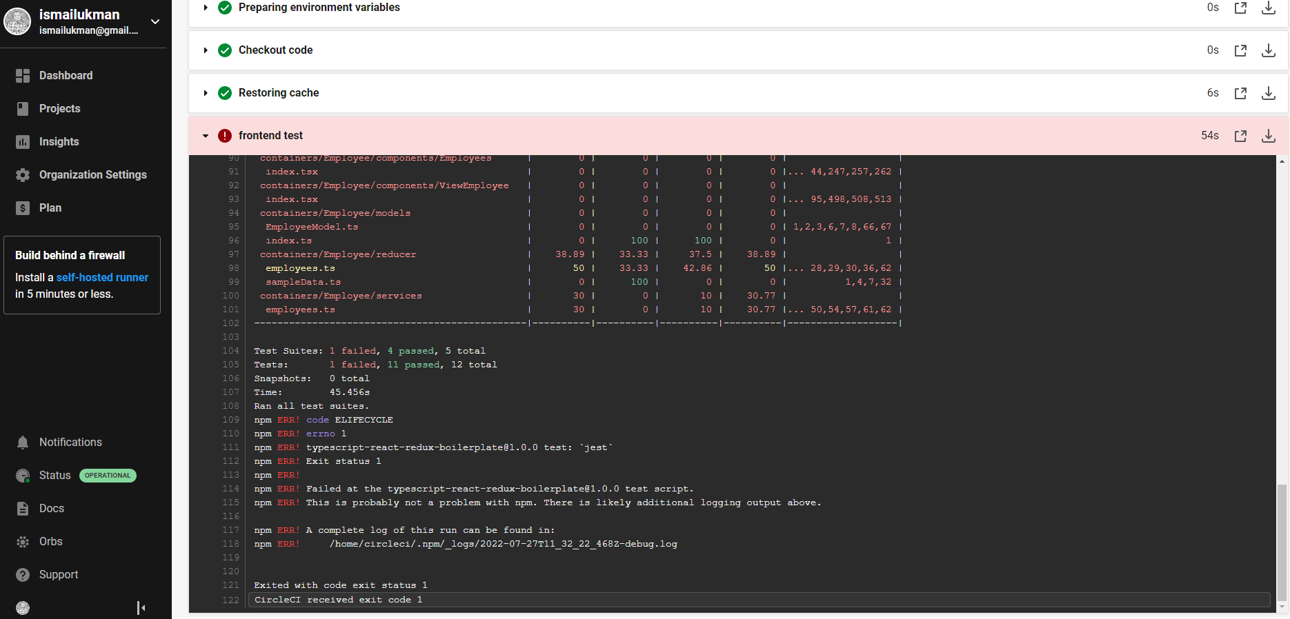

1. Job that failed because of vulnerable packages. [SCREENSHOT03]

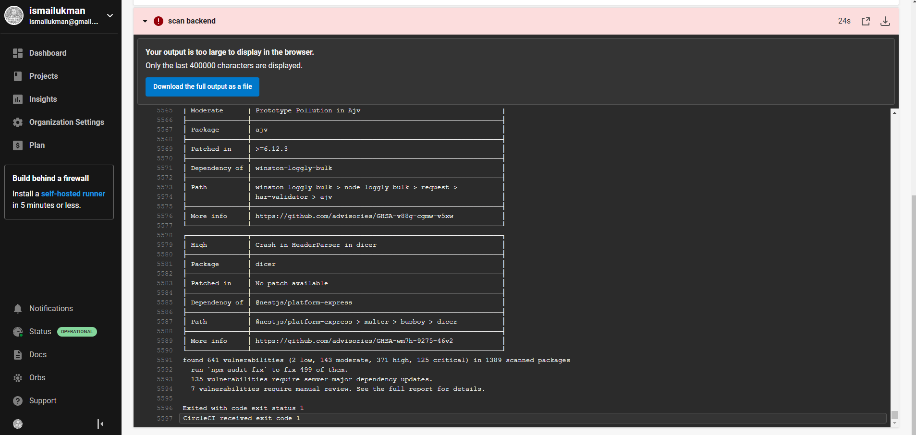

1. An alert from one of your failed builds. [SCREENSHOT04]

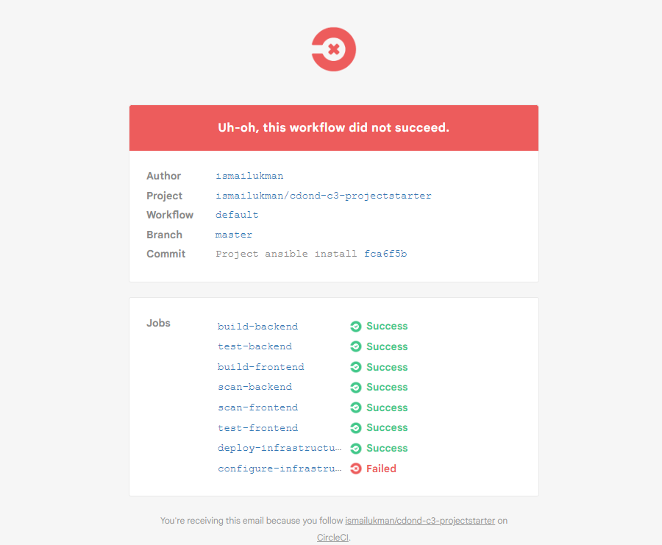

1. Appropriate job failure for infrastructure creation. [SCREENSHOT05]

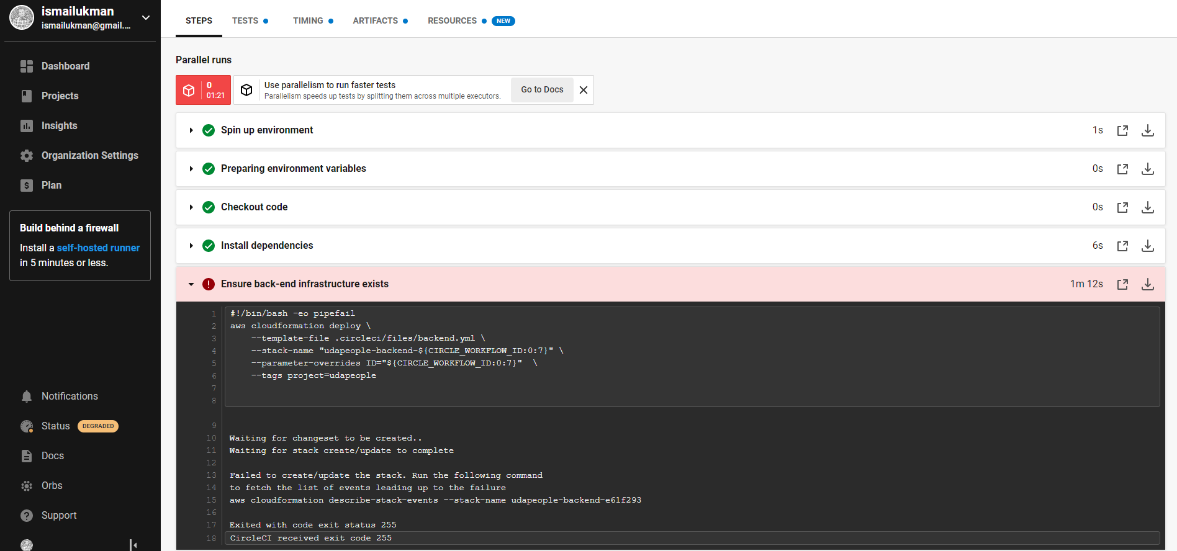

1. Appropriate job failure for the smoke test job. [SCREENSHOT06]

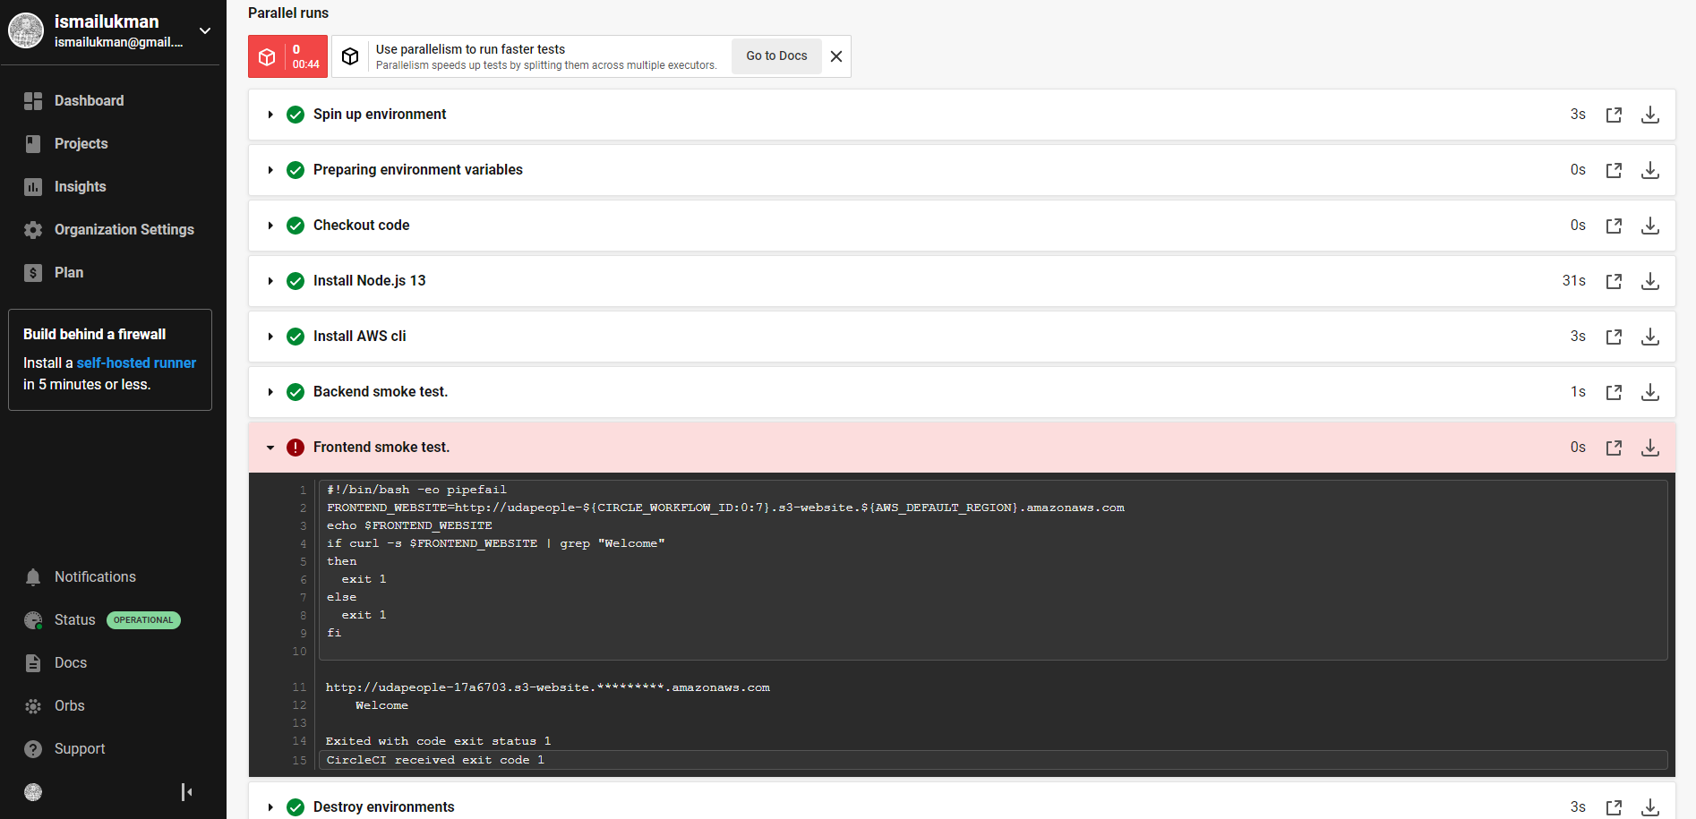

1. Successful rollback after a failed smoke test. [SCREENSHOT07]

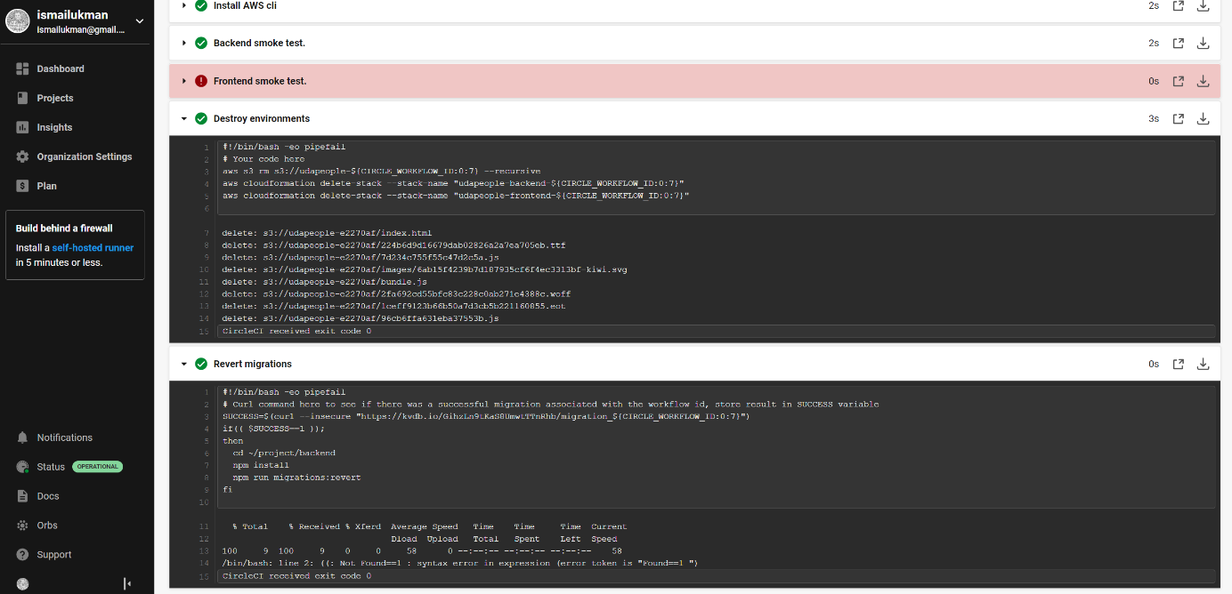

1. Successful promotion job. [SCREENSHOT08]

1. Successful cleanup job. [SCREENSHOT09]

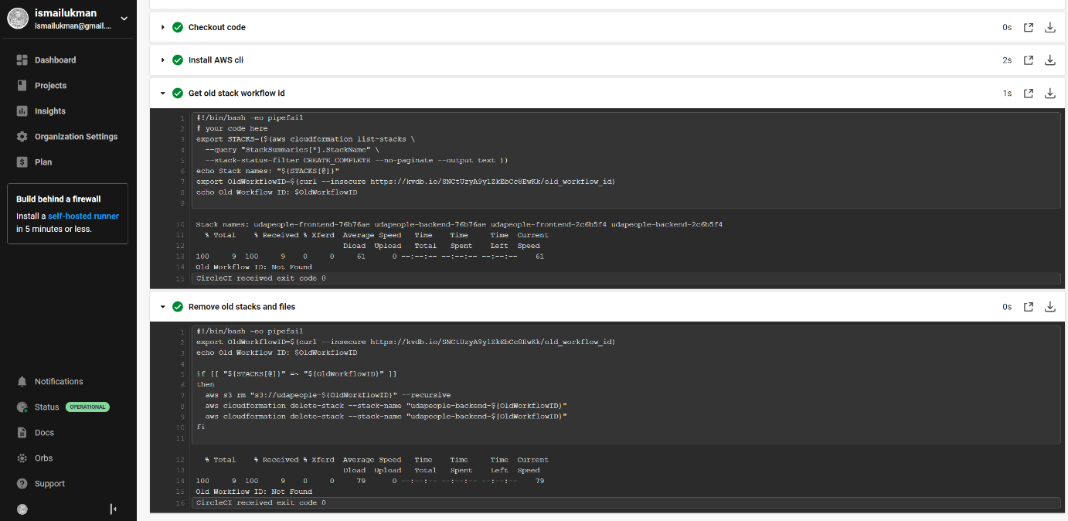

1. Only deploy on pushed to master branch. [SCREENSHOT10]

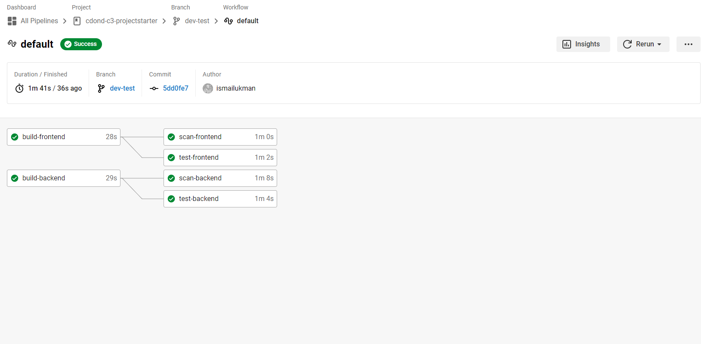

1. Provide a screenshot of a graph of your EC2 instance including available memory, available disk space, and CPU usage. [SCREENSHOT11]

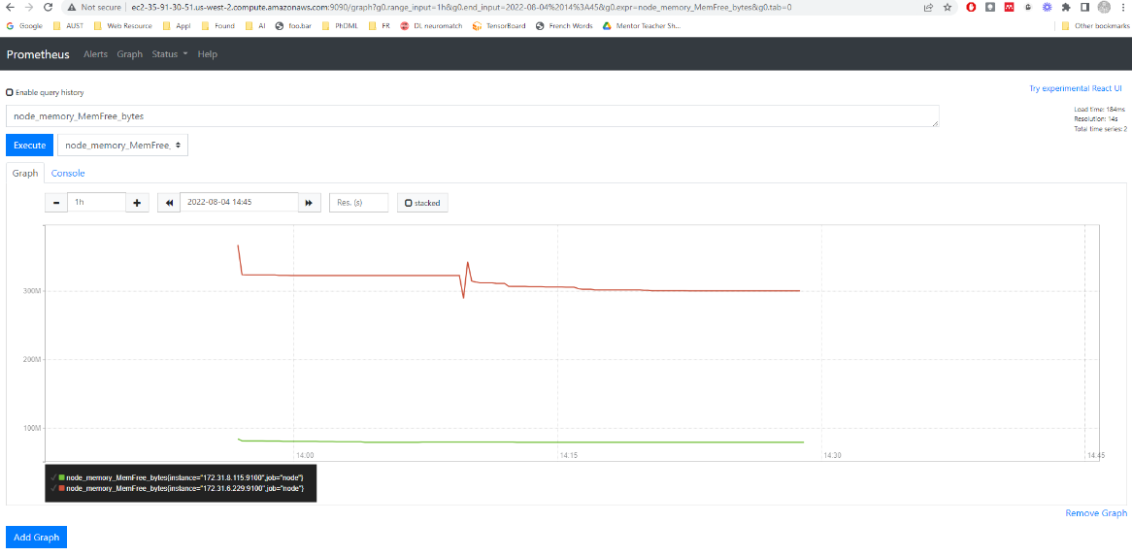

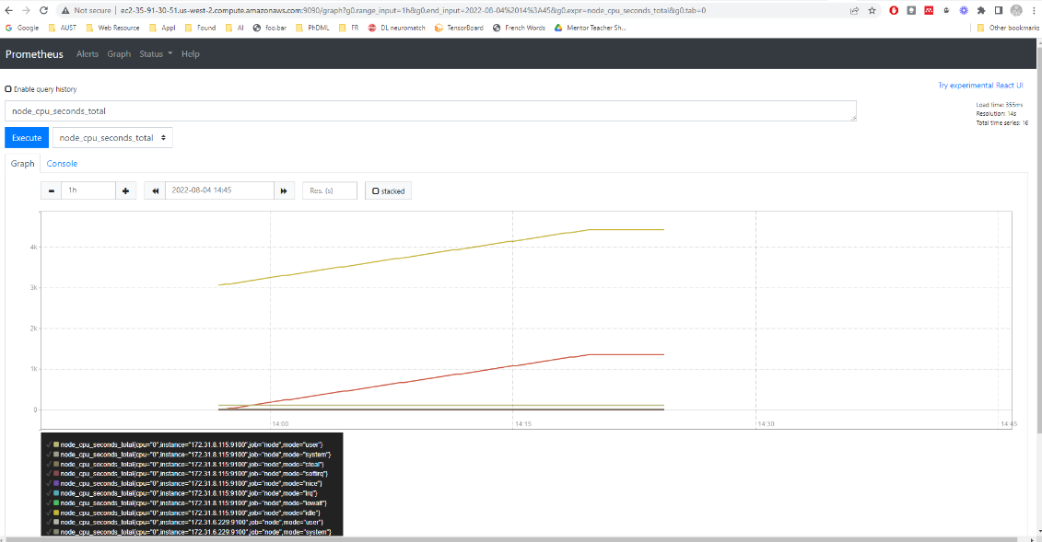

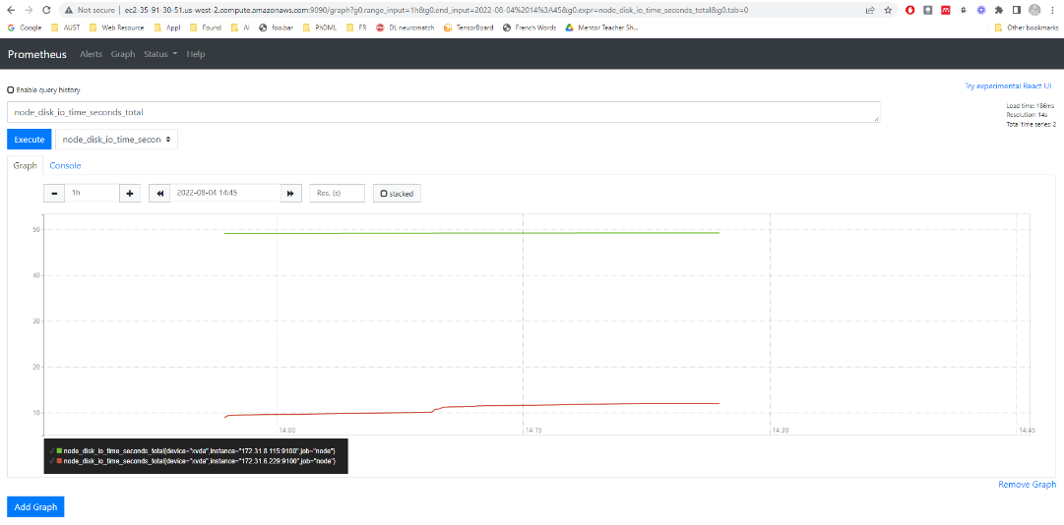

1. Provide a screenshot of an alert that was sent by Prometheus. [SCREENSHOT12]

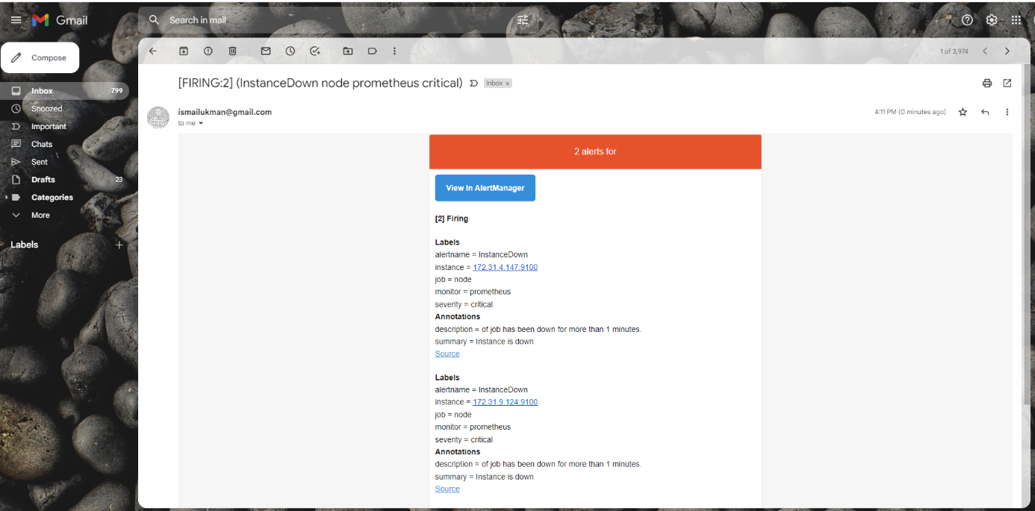

1. Provide a screenshot showing the evidence of deployed and functioning front-end application in CloudFront (aka, your production front-end). [URL03_SCREENSHOT]

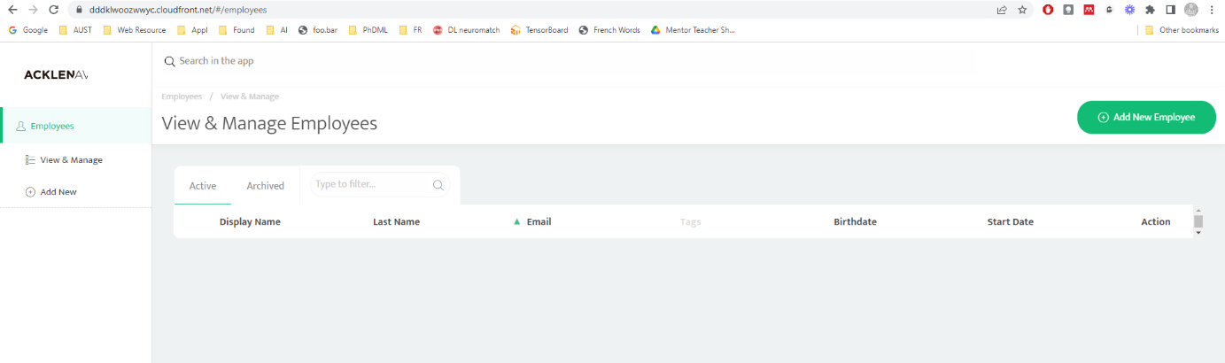

1. Provide a screenshot showing the evidence of a healthy backend application. The backend endpoint status should show a healthy response. [URL04_SCREENSHOT]

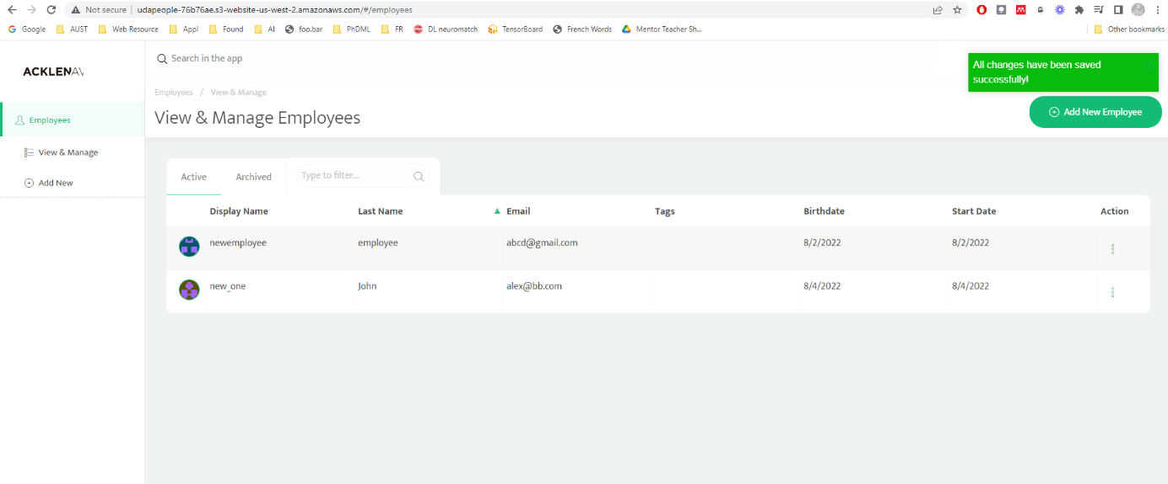

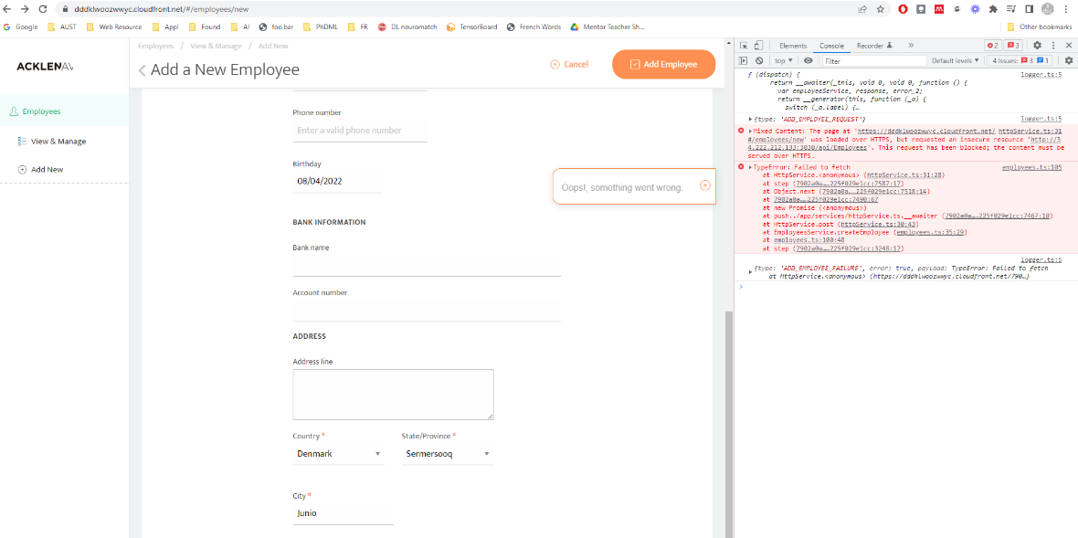

1. Provide a screenshot of your Prometheus server showing UP state [URL05_SCREENSHOT]

